Fifty Years of Nation-Making:
A Revitalised Papua New Guinea Dictionary of Biography is Launched
By Nicholas Hoare with Theresa Meki and Keimelo Gima
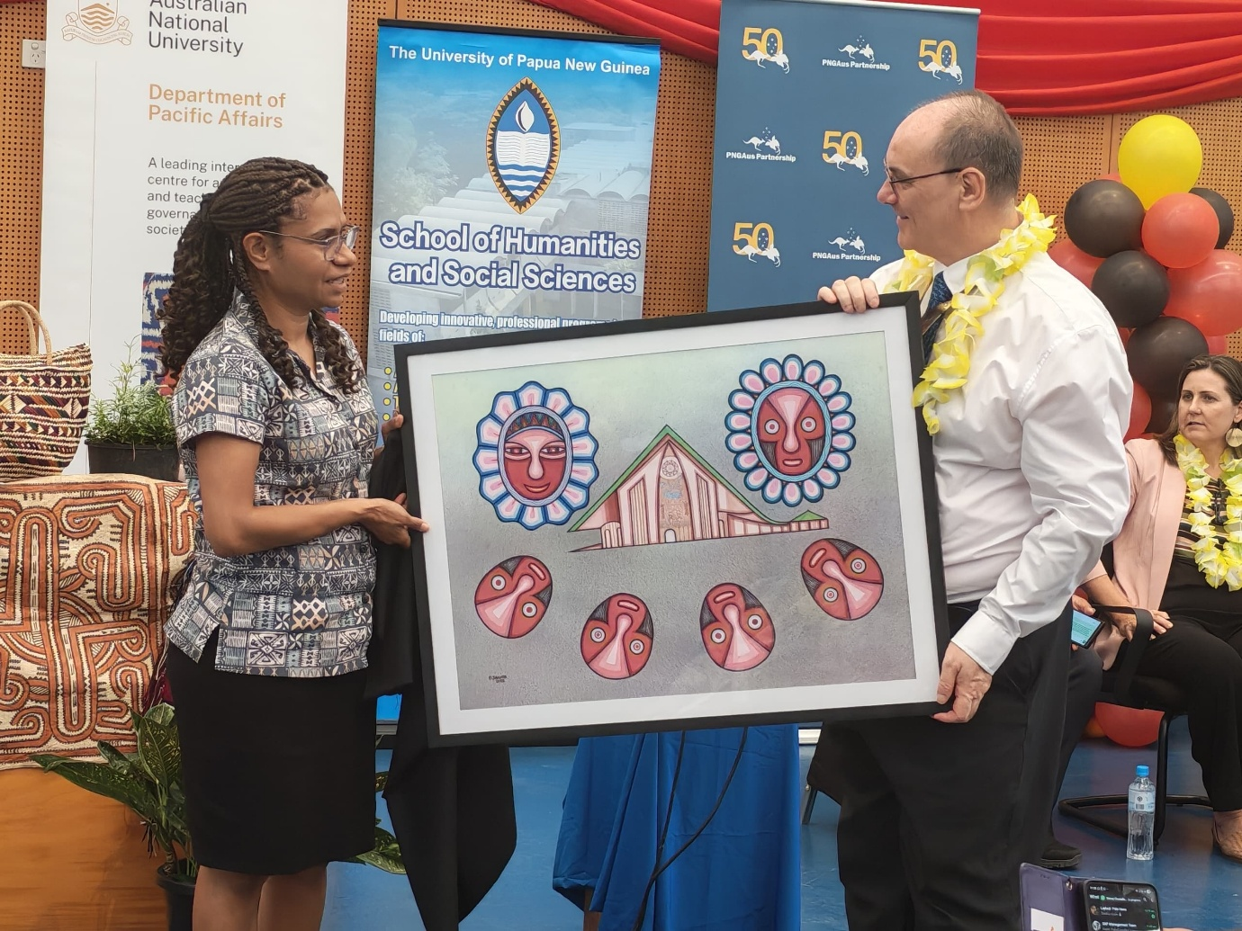
Figure 1: Volume One editor Dr Theresa Meki with UPNG Vice-Chancellor Professor Ian Findlay. Credit Gelinde Narekine.
With the golden jubilee celebrations and a three-day public holiday having just passed, Papua New Guinea is equal parts festive and reflective. The national broadcasters have played their part in fostering the later: screening history-themed documentaries and news segments in between the comprehensive live coverage of official events across the nation’s capital. For the last two weeks, universities and training centres such as the Somare Institute of Leadership and Governance have organised symposia, seminars and public lectures on PNG’s past, present, and future.
Nation building has been at the heart of it all. And before the party atmosphere took over Sir John Guise Stadium on the night of the 16th, the centrepiece of the official program was a parade of historical portraits celebrating Papua New Guinean nation builders from the past 50 years: the prime ministers, the constitutional planners, the public servants, and the cultural icons such as the designer of the PNG flag, Susan Karike, and composer of ‘O Arise, All You Sons’, Thomas Shacklady. With many of the portraits being carried to the stage by descendants, it was a powerful and emotional program that showcased PNG’s rich and varied history.
Our new edited collection, Fifty Years of Nation-Making: A Papua New Guinea Dictionary of Biography, Volume One (Department of Pacific Affairs, 2025), seeks to do something similar. Inspired by anthropologist Robert J. Foster’s use of nation-making – encompassing grassroots, informal, ongoing and contingent forms of community organisation – ahead of nation-building with its formal, state-centric connotations, the volume celebrates the lives and careers of an eclectic range of Papua New Guinean personalities, many of whom are still with us today and in the twilight of their careers.
By sidestepping Prime Ministers in Volume One, the biographical entries speak strongly to popular misgivings about the state of leadership in the country and its many challenges such as provincial and urban development, decentralisation, peacebuilding, public service reform and education. As a book of reference, it settles a longstanding debate about who was the first Papua New Guinean to be awarded a PhD (the answer is biologist and medical doctor David Linge; John Waiko was the first graduate in the social sciences). But as a Papua New Guinean Dictionary of Biography, each biographer is centred through an introductory positionality statement, making it clear that these biographies are only portraits in time and not the definitive account.
Much like nation-making itself, researching, writing and editing these biographies is an ongoing process open to contestation and competing approaches. The project is the rejuvenation of an earlier UPNG project and while Volume One was launched at the University of Papua New Guinea (UPNG) on the 11th of September, there is no reason why subsequent volumes cannot have significant input from universities and research institutes from around the nation. Indeed, Volume One includes authors from UPNG, University of Goroka, Divine Word University, as well as Papua New Guinean academics and students from overseas universities and outside of academia altogether.
One of the strengths of this volume is its range of perspectives. Many of the biographies have been written by descendants such as Dame Kila Amini by her son and daughter, Cheryl and Charles, Lucy Apako (Joseph) by daughter Jacqueline Joseph, Kuri Dom by granddaughter Illeana Dom, Peter Donigi by nephew Alan Donigi, Walla Gukguk by daughter Tukul Kaiku, Rev. Ray Lahui-Ako by son Lahui Ako, Muriel Larner by daughter Rosalie Everest, Annlyn Mota by daughter Julie Kondi, Bernard Narokobi by son Vergil Narokobi. Many of the others have been written by friends and colleagues. Of the few Australian contributors, musician David Bridie’s tribute to his long-time friend and artistic collaborator ‘Sir’ George Telek stands out. Telek is a perfect example of someone taking PNG to the world and Bridie speaks from close experience about musical legends David Byrne and Peter Gabriel being floored by Telek’s music in the 1990s.
As editors, we argue that collective biography is an ideal vehicle for the telling of modern Papua New Guinean history, especially given the much commented upon complexity and diversity of this nation. The extra layer of engaged and relational writing is a long way from the old-fashioned standards of distance and objectivity that mark much older dictionaries of national biography in other parts of the world. There is further scope for experimentation in form and style – once again drawing from the rich history of Papua New Guinean writing and innovative work by Indigenous Pacific scholars working with the Oceania Working Party of the Australian Dictionary of Biography – but the goal remains to make this a readable book of reference aimed predominantly at university and high school students.
To finish with an anecdote, the importance of this relational approach was underscored at our UPNG launch when Grace Dom, daughter of the late Kuri Dom (of whom the UPNG Humanities and Social Sciences building is named), spoke to the audience about the various emotions this process has evoked for her. Kuri, a UPNG social scientist and social worker, tragically passed away while completing his PhD in London. And, to paraphrase Grace’s words, she was struck by two things. First, by looking at the other entries in this volume – mostly of Papua New Guineans from her father’s generation – it reminded her of what her father could have become if he did not die at such a young age. Second, for her daughter, Illeana – who never got to meet her grandfather – undertaking research about Kuri was a way for her to remain connected to her family and PNG culture despite having become a global citizen, undertaking higher education in Japan.
We doubt that Grace’s two observations are unique to the Dom family and if this project can continue to offer these kinds of opportunities for the next generation of Papua New Guinean leaders to learn from the past, it will have served its purpose.

