January 2026 aid news
Generated: 1/27/2026
Legend: | Inserted text

Australian aid

The government has announced that it will provide a further $550 million in capital for the Australian Infrastructure Financing Facility for the Pacific (AIFFP). It has not said how much of this finance will be non-concessional loans versus grants, nor whether any grant finance would be additional to the 2025-26 aid budget. The AIFFP has relied heavily on grants to date and has likely committed all of its existing $1 billion grant finance cap.

Export Finance Australia has established a loan facility of up to $US35 million for PNG. The facility will help secure finance from the Asian Development Bank (ADB) to PNG’s state-owned carrier, Air Niugini, for the purchase of new aircraft.

Visiting Dili, Prime Minister Anthony Albanese has pledged a “new era” in bilateral relations and committed a further $8 million in technical assistance to support Timor-Leste’s recent accession to ASEAN. He also re-iterated a commitment to establish a new, “co-designed” Infrastructure Fund for Timor-Leste once a commercial arrangement for the exploitation of the Greater Sunrise gas field is approved by the two countries. The Fund will be financed from Australia’s revenues from the project.

The government has said that it will consider an invitation from the Trump administration for Prime Minister Albanese to join the US-led "Board of Peace" for up to three years. To gain a permanent seat members would each have to contribute US$1 billion. Around 24 countries have already joined the board, including Indonesia, Israel, and Saudi Arabia. President Donald Trump will chair the body and hold the sole veto over its membership and decisions. Canada has been disinvited. Critics have said that the organisation is aimed at further undermining the role of the UN.

The OECD Development Assistance Committee (DAC) has released its 2025 peer review of Australia's aid program. The peer review puts forward ten recommendations that encompass Australian aid funding, effectiveness, policy coherence, capability, and public and parliamentary engagement. You can read analysis of the peer review on the Devpolicy blog.

The DAC has also released its final statistics for Official Development Assistance (ODA) from its 32 member countries in 2024 (Figure 1). Australia ranked 28/32 on aid generosity (ODA as a share of gross national income, 0.19%) and 15/32 on aid volume (US$3.38 billion). In 2021, the final year of the Morrison government, Australia ranked 21st on aid generosity and 13th on aid volume.

Figure 1: ODA provided by members of the OECD Development Assistance Committee, 2024

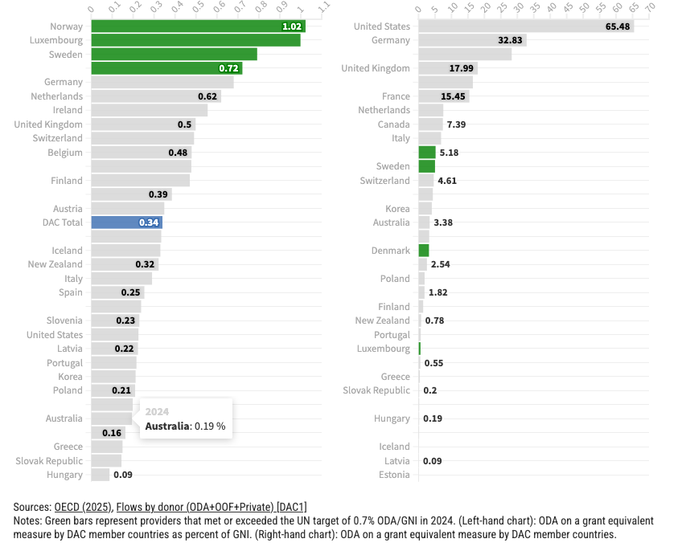

Total annual, grant-equivalent ODA from DAC donors in 2024 (US$215 billion) fell by 6% in real terms year-on-year, the first time in six years that global ODA has fallen. The OECD projects a further fall of between 10% and 18% in 2025 which would see ODA decline back to 2015 levels. Preliminary ODA data for 2025 will be released in the coming months.

Regional/global aid

The World Bank and the ADB have chosen two Pacific projects — a health project in Fiji and a transport and urban development project in Tonga — as the first to be delivered under their new joint co-financing framework. The framework promises “faster project implementation, lower transaction costs, and continued adherence to high policy standards”. In 2023, the World Bank and the ADB provided almost US$340 million in ODA to the Pacific.

The UK government has released a new “Small Island Developing States Strategy”. In the Pacific, the strategy emphasises UK support for “blended” and multilateral development finance, as well as climate change adaptation. Globally, UK ODA funding will be cut by around 40% from 2025 levels by 2027.

The Trump administration has promised more bilateral aid to Palau in return for its acceptance of 75 “third country nationals” who cannot be returned to their country of origin. Some of the additional aid will be used to shore up Palau’s civil service pension system, as well as improve health facilities. Unlike the people transferred to Nauru under Australia’s recent deal, the transferees do not have criminal histories.

The US Congress appears to be pushing back against the Trump administration’s aid cuts, passing a US$50 billion allocation for “national security, Department of State and related programs” in its FY2026 budget appropriation bill. This is US$20 billion more than that proposed by the White House. The aid components, worth around US$30 billion, would partially restore funding for global health programs, humanitarian and bilateral assistance, and multilateral aid (with heavy conditionalities). An overall spending deal needs to be finalised by the end of January to avoid another government shutdown. Even if passed, a budget deal could be subject to future presidential recissions.

As part of a defence bill, the Congress has also re-authorised the US Development Finance Corporation (DFC), establishing provisions for a US$5 billion revolving investment fund and increasing its maximum liability cap from US$60 billion to US$205 billion. Of this cap, the bill allows for up to 10% of DFC investments to be in high income countries. The DFC has been mooted as a vehicle through which the Trump administration could pursue its ambitions for greater access to critical minerals in Greenland and elsewhere.

As foreshadowed, the US has announced that it will expand its restrictions on aid for sexual and reproductive health programs to also include restrictions on funding for “diversity, equity and inclusion” programs, as well as those that promote “gender ideology”.

The Trump administration has announced that it will unilaterally withdraw from 66 international agencies, organisations and treaty bodies, including 31 UN bodies. It says participation in these bodies is “contrary to the interests of the United States”. Some of these “withdrawals” may simply involve not attending meetings and/or cutting funding, while others might legally require congressional approval. The US has also officially withdrawn from the World Health Organization, leaving a US$260 million bill in unpaid assessed contributions.

Against the backdrop of its threat that other UN agencies must “adapt, shrink or die” the Trump administration has struck a US$2 billion deal to support the UN Office for the Coordination of Humanitarian Affairs’ so-called “humanitarian reset”. The specific conditions of the deal, including so-called “negative earmarks” that might exclude some forms of assistance or aid to some populations, have not been made public. Support for tens of millions of vulnerable people in Gaza, Afghanistan, and Yemen is also excluded from the funding deal.

Several Western states and the UN have condemned the Netanyahu government’s use of new regulations that threaten to ban dozens of international humanitarian aid organisations from operating in Gaza and its demolition of the headquarters of the UN agency for Palestinian refugees (UNRWA) in occupied East Jerusalem.

The ABC has been granted rare access to Afghanistan to report on communities displaced by the 2025 earthquakes and the plight of women and girls under the Taliban.

Books, reports, articles, podcasts etc.

Nilima Gulrajani from ODI Global discusses what the shift from a “peak aid” to a “post aid” world might look like in the latest issue of Current History.

In their latest look at climate finance, Publish What You Fund finds a persistent gap (US$27 billion in 2024) between the level of climate funding claimed by the multilateral development banks in their reporting and that which can be identified through project-level disaggregated data.

The Multilateral Performance Network (MOPAN) has published the results of a survey on how funding reductions as large as 50% across the multilateral development, humanitarian and health system are affecting individual agencies and organisations.

Monique Taylor takes a look at the operations and constraints facing the Marshall Islands’ unique and largely donor-funded universal basic income scheme on the East Asia Forum blog.

And a stark map from the EU’s humanitarian agency depicts the vast, transnational scope and scale of the humanitarian crisis in Sudan, the world’s largest (Figure 2).

Figure 2: Sudan crisis map

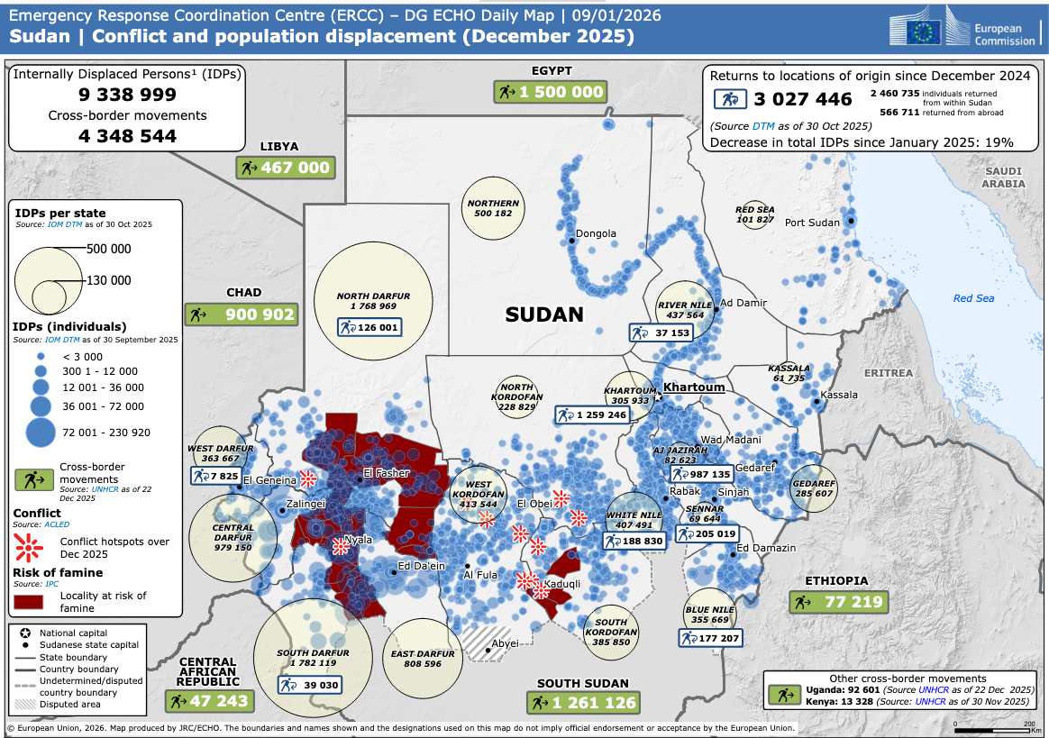

Source: European Commission, Directorate-General for European Civil Protection and Humanitarian Aid Operations, 9 January 2026.

